
9 March 2025 | 9am
The First Sunday of Lent

WELCOME to St Peter’s Church today. I am delighted that you can join us in worship.

If you are a newcomer or visiting, I especially look forward to meeting you and hope that you feel welcome. If you have any questions, do not hesitate to ask one of the greeters at the door, or someone in the pew next to you.

I hope you can stay and enjoy morning tea after the service.
Rev Mark Wormell, Acting Rector.

Today’s Service

Sung Eucharist

celebrant & preacher | rev. mark wormell
organist & cantor | glenn amer
setting | dudman

Rejoicing Together In Christ

A Hearing Loop is available in the pews on the left-hand side of the church. Toilets are available in the Lower Hall and a mobility access toilet in the David Armstrong Room.

GATHERING IN GOD'S NAME

PROCESSIONAL HYMN
Please stand Tune: Heinlein

1 | Forty days and forty nights  Thou wast fasting in the wild;  Forty days and forty nights  Tempted, and yet undefiled.
2 | Sunbeams scorching all the day;  Chilly dew-drops nightly shed;  Prowling beasts about your way;  Stones thy pillow; earth thy bed.
3 | Shall not we thy trial share,  And from earthly joys abstain,  Fasting with unceasing prayer,  Strong with thee to suffer pain?
4 | And if Satan, vexing sore,  Flesh or spirit should assail,  thou, his vanquisher before,  Grant we may not faint or fail.
5 | So shall we have peace divine;  Holier gladness ours shall be;  Round us, too, shall angels shine,  Such as ministered to thee.
6 | Keep, oh, keep us, Savior dear,  Ever constant by thy side;  That with thee we may appear  At the eternal Eastertide.

George Hunt Smyttan, 1822 - 1870

The Celebrant greets the people with a welcome.

 Blessed be God: Father, Son, and Holy Spirit.
Blessed be God’s Kingdom, now and for ever.

The grace of the Lord Jesus Christ, and the love of God, and the fellowship of the Holy Spirit, be with you.
And also with you.

SENTENCE

Worship the Lord your God, and serve only him. Luke 4.8

Let us pray.

Almighty God,
to whom all hearts are open,
all desires known,
and from whom no secrets are hidden:
cleanse the thoughts of our hearts
by the inspiration of your Holy Spirit,
that we may perfectly love you,
and worthily magnify your holy name,
through Christ our Lord. Amen.

KYRIE ELEISON
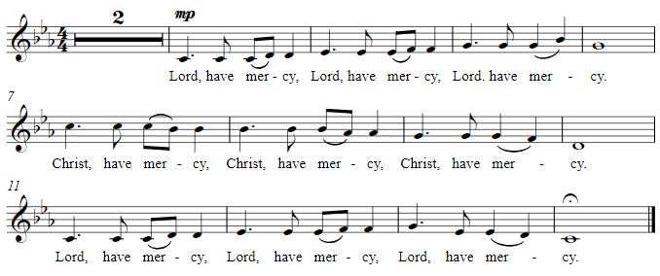

THE CONFESSION

Senior Server
God shows great love for us in that while we were still sinners Christ died for us.
Silence

Let us then confess our sins in penitence and faith.

Merciful God,
our maker and our judge,
we have sinned against you in thought, word, and deed,
and in what we have failed to do:
we have not loved you with our whole heart;
we have not loved our neighbours as ourselves;
we repent, and are sorry for all our sins.
Father, forgive us. Strengthen us to love and obey you in
newness of life; through Jesus Christ our Lord. Amen.

THE ABSOLUTION

Celebrant
Almighty God, who has promised forgiveness to all who turn to him in faith:
 pardon you and set you free from all your sins, strengthen you in all goodness and keep you in eternal life, through Jesus Christ our Lord. Amen.

COLLECT OF THE DAY

O saving God,
who led your people through the wilderness
and brought them to the promised land:
so guide us that, following our Saviour,
we may walk through the wilderness of this world
and be brought to the glory of the world which is to come;
through your Son, Jesus Christ our Lord,
who lives and reigns with you and the Holy Spirit,
one God, now and for ever.
Amen.

THE MINISTRY OF THE WORD
Please be seated.

THE FIRST READING

A reading from the Book of Deuteronomy 26:1-11

When you have entered the land that the Lord your God is giving you as an inheritance and have taken possession of it and settled in it, ² take some of the firstfruits of all that you produce from the soil of the land that the Lord your God is giving you and put them in a basket. Then go to the place that the Lord your God will choose as a dwelling for his Name ³ and say to the priest in office at the time, ‘I declare today to the Lord your God that I have come to the land the Lord swore to our ancestors to give us.’ ⁴ The priest shall take the basket from your hands and set it down in front of the altar of the Lord your God. ⁵ Then you shall declare before the Lord your God: ‘My father was a wandering Aramean, and he went down into Egypt with a few people and lived there and became a great nation, powerful and numerous. ⁶ But the Egyptians ill-treated us and made us suffer, subjecting us to harsh labour. ⁷ Then we cried out to the Lord, the God of our ancestors, and the Lord heard our voice and saw our misery, toil and oppression. ⁸ So the Lord brought us out of Egypt with a mighty hand and an outstretched arm, with great terror and with signs and wonders. ⁹ He brought us to this place and gave us this land, a land flowing with milk and honey; ¹⁰ and now I bring the firstfruits of the soil that you, Lord, have given me.’ Place the basket before the Lord your God and bow down before him. ¹¹ Then you and the Levites and the foreigners residing among you shall rejoice in all the good things the Lord your God has given to you and your household.

Hear the Word of the Lord, thanks be to God.

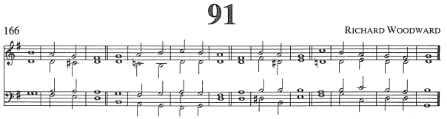

1 | He who dwells in the shelter of the | Most | High:  who abides under the | shadow | of the • Al|mighty,
2 | He will say to the Lord ‘You are my refuge | and my | stronghold: my | God in | whom I | trust.’
9 | The Lord him|self • is your | refuge:  you have | made the • Most | High your | stronghold.
10 | Therefore no | harm • will be|fall you:  nor will any | scourge come | near your | tent.
11 | For he will com|mand his | angels:  to | keep you • in | all your | ways.
12 | They will bear you | up • in their | hands:  lest you dash your | foot a|gainst a | stone.
13 | You will tread on the | lion • and the | adder:  the young lion and the serpent‿ you will | trample | under | foot.
14 | ‘He has set his love upon me. and therefore | I will de|liver him:  I will lift him out of danger‿ be|cause • he has | known my | name.
15 | ‘When he calls upon me | I will | answer him:  I will be with him in trouble I will | rescue him • and | bring him • to | honour.
16 | ‘With long | life • I will | satisfy him:  and | fill him • with | my sal|vation.’

THE SECOND READING

A reading from the letter of Paul to the Romans 10:4-13

Christ is the culmination of the law so that there may be righteousness for everyone who believes. ⁵ Moses writes this about the righteousness that is by the law: ‘The person who does these things will live by them.’ ⁶ But the righteousness that is by faith says: ‘Do not say in your heart, “Who will ascend into heaven?”’ (that is, to bring Christ down) ⁷ ‘or “Who will descend into the deep?”’ (that is, to bring Christ up from the dead). ⁸ But what does it say? ‘The word is near you; it is in your mouth and in your heart,’ that is, the message concerning faith that we proclaim: ⁹ if you declare with your mouth, ‘Jesus is Lord,’ and believe in your heart that God raised him from the dead, you will be saved. ¹⁰ For it is with your heart that you believe and are justified, and it is with your mouth that you profess your faith and are saved. ¹¹ As Scripture says, ‘Anyone who believes in him will never be put to shame.’ ¹² For there is no difference between Jew and Gentile – the same Lord is Lord of all and richly blesses all who call on him, ¹³ for, ‘Everyone who calls on the name of the Lord will be saved.’

Hear the Word of the Lord, thanks be to God.

GOSPEL ACCLAMATION
All stand

Cantor
Praise to you Lord Jesus Christ, king of endless glory!

Praise to you Lord Jesus Christ, king of endless glory!

It is written ‘worship the Lord your God and serve only him.’
Praise to you Lord Jesus Christ, king of endless glory!

The Lord be with you.
And also with you.

The Gospel of our Lord Jesus Christ according to Luke 4:1-15

Jesus, full of the Holy Spirit, left the Jordan and was led by the Spirit into the wilderness, ² where for forty days he was tempted by the devil. He ate nothing during those days, and at the end of them he was hungry. ³ The devil said to him, ‘If you are the Son of God, tell this stone to become bread.’ ⁴ Jesus answered, ‘It is written: “Man shall not live on bread alone.”’ ⁵ The devil led him up to a high place and showed him in an instant all the kingdoms of the world. ⁶ And he said to him, ‘I will give you all their authority and splendour; it has been given to me, and I can give it to anyone I want to. ⁷ If you worship me, it will all be yours.’ ⁸ Jesus answered, ‘It is written: “Worship the Lord your God and serve him only.”’ ⁹ The devil led him to Jerusalem and had him stand on the highest point of the temple. ‘If you are the Son of God,’ he said, ‘throw yourself down from here. ¹⁰ For it is written: ‘“He will command his angels concerning you to guard you carefully; ¹¹ they will lift you up in their hands, so that you will not strike your foot against a stone.”’ ¹² Jesus answered, ‘It is said: “Do not put the Lord your God to the test.”’ ¹³ When the devil had finished all this tempting, he left him until an opportune time. ¹⁴ Jesus returned to Galilee in the power of the Spirit, and news about him spread through the whole countryside. ¹⁵ He was teaching in their synagogues, and everyone praised him.’

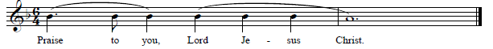
This is the Gospel of the Lord.

SERMON
Please sit

HYMN
Please stand Tune: St Bees

1 | Sinful, sighing to be blessed;  bound, and longing to be free;  weary, waiting for my rest:  God be merciful to me.
2 | Goodness I have none to plead,  sinfulness in all I see,  I can only bring my need:  God be merciful to me.
3 | Broken heart and downcast eyes  dare not lift themselves to thee;  yet thou canst interpret sighs:  God be merciful to me.
4 | From this sinful heart of mine  to thy bosom I would flee:  I am not mine own, but thine:  God be merciful to me.
5 | There is One beside the throne,  and my only hope and plea  are in him and him alone:  God be merciful to me.
6 | He my cause will undertake,  my interpreter will be;  he's my all; and for his sake  God be merciful to me.
Rev J. S. B. Monsell 1811 - 1875

THE NICENE CREED

Senior Server

Let us together affirm the faith of the Church:

We believe in one God, the Father,
the almighty, maker of heaven and earth,
of all that is, seen and unseen.
We believe in one Lord, Jesus Christ,
the only Son of God,
eternally begotten of the Father,
God from God, Light from Light,
true God from true God,
begotten, not made,
of one being with the Father;
through him all things were made.
For us and for our salvation he came down from heaven,
was incarnate of the Holy Spirit and the virgin Mary
and became truly human.
For our sake he was crucified under Pontius Pilate;
he suffered death and was buried.
On the third day he rose again in accordance
with the Scriptures;
he ascended into heaven
and is seated at the right hand of the Father.
He will come again in glory to judge the living
and the dead and his kingdom will have no end.
We believe in the Holy Spirit, the Lord, the giver of life
who proceeds from the Father and the Son, who with the Father and the Son is worshipped and glorified, who has spoken through the prophets.
We believe in one holy catholic and apostolic Church.
We acknowledge one baptism for the forgiveness of sins.
We look for the resurrection of the dead,
 and the life of the world to come. Amen.

THE PRAYERS OF THE PEOPLE

Senior Server
Let us pray for the world and for the Church.

All sit/kneel

Periods of silence may be briefly kept for personal prayer. Each petition ends with this response: Lord in your mercy, Hear our prayer.

Accept our prayers through Jesus Christ our Lord.
As Christ has taught us, we pray:

Our Father in heaven,
hallowed be your name, your kingdom come,
your will be done, on earth as in heaven.

Give us today our daily bread.

Forgive us our sins as we forgive those who sin against us.

Save us from the time of trial

and deliver us from evil.

For the kingdom, the power, and the glory are yours,

now and for ever. Amen

PREPARATION FOR HOLY COMMUNION
All stand

Celebrant
Hear the words of assurance for those who truly turn to Christ:

Jesus said: Come to me, all who labour and are heavy laden, and I will give you rest. Matthew 11.28

God so loved the world that he gave his only Son, that whoever believes in him should not perish but have eternal life. John 3.16

We do not presume to come to your table, merciful Lord,
trusting in our own righteousness,
but in your manifold and great mercies.
We are not worthy so much as to gather up the crumbs under
your table.
But you are the same Lord whose nature is always to have mercy.
Grant us, therefore gracious Lord,
so to eat the flesh of your dear Son Jesus Christ,
and to drink his blood, that we may evermore dwell in him,
and he in us. Amen.

THE GREETING OF PEACE

We are the body of Christ.
His Spirit is with us.

The peace of the Lord be always with you.
And also with you.

All are invited to greet those immediately around them with the words, “Peace be with you” “And also with you”.

THE GREAT THANKSGIVING
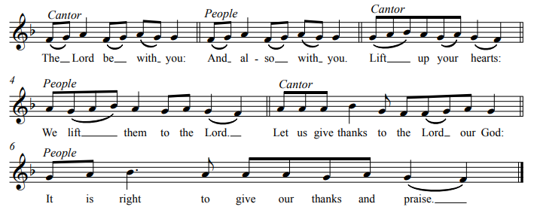

All glory and honour be yours always and everywhere, mighty Creator, ever living God.

We give you thanks and praise for our Saviour Jesus Christ, who by the power of your Spirit was born of Mary and lived as one of us.

By his death on the cross and rising to new life, he offered the one true sacrifice for sin and obtained an eternal deliverance for his people.

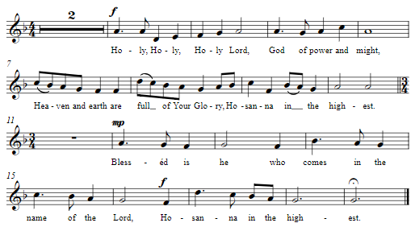
Therefore with angels and archangels and with all the company of heaven, we proclaim your great and glorious name, for ever praising you and singing:

Merciful God, we thank you for these gifts of your creation, this bread and wine, and we pray that by your Word and Holy Spirit, we who eat and drink them may be partakers of Christ’s body and blood.

On the night when he was betrayed Jesus took bread; and when he had given you thanks he broke it, and gave it to his disciples, saying, ‘Take, eat. This is my body given for you. Do this in remembrance of me.’

After supper, he took the cup, and again giving you thanks he gave it to his disciples, saying, ‘Drink from this, all of you. This is my blood of the new covenant shed for you and for many for the forgiveness of sins. Do this, as often as you drink it, in remembrance of me.’

Therefore we do as our Saviour has commanded: proclaiming his offering of himself made once for all upon the cross, his mighty resurrection and glorious ascension, and looking for his coming again, we celebrate, with this bread and this cup, his one perfect and sufficient sacrifice for the sins of the whole world.

Cantor
Let us proclaim the mystery of faith,

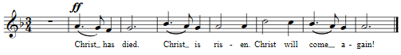

Renew us by your Holy Spirit, unite us in the body of your Son, and bring us with all your people, into the joy of your eternal kingdom; through Jesus Christ our Lord, with whom, and in whom, in the fellowship of the Holy Spirit, we worship you, Father, in songs of never-ending praise.
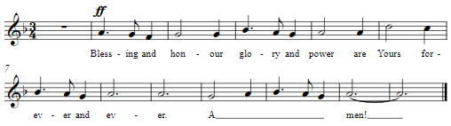
THE BREAKING OF THE BREAD

The celebrant breaks the bread.

We break this bread to share in the body of Christ. We who are many are one body,

for we all share in the one bread.
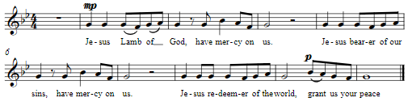
AGNUS DEI

INVITATION

The gifts of God for the people of God.
Come let us take this holy sacrament of the body and blood of Christ in remembrance that he died for us, and feed on him in our hearts by faith
with thanksgiving.

As the sacrament is received the communicant responds. Amen.

All baptised Christians who love and serve the Lord Jesus are welcome
to join in the sharing of Holy Communion. If you are not yet ready to
receive Communion, we encourage you to come forward for a prayer of blessing. Please indicate your desire for a blessing by holding your hands behind your back.

Alcoholic wine is available in the Common Cup, and both alcoholic and non-alcoholic wine is available in individual cups. If you prefer an individual cup, please take one on your way to the Communion Rail.

After receiving communion, the congregation sits or kneels. Silence for prayerful reflection may be kept.

SENTENCE
Jesus answered, “It is said: ‘Do not put the Lord your God to the test.’”
¹³ When the devil had finished all this tempting, he left him until an opportune time. Luke 4:12 - 13
PRAYER AFTER COMMUNION
All stand

Let us pray.
Gracious God, we thank you that in this sacrament you assure us of your goodness and love. Accept our sacrifice of praise and thanksgiving and help us grow in love and obedience that we may serve you in the world and finally be brought to that table where all your saints feast with you for ever.

Father, we offer ourselves as a living sacrifice through Jesus Christ our Lord. Send us out in the power of your Spirit to live and work to your praise and glory. Amen.

PRAYER FOR OFFERTORY

Gracious God, all things come from you, and you teach us to be generous with what we have. We pray that our gifts may be wisely used for the ministry of the gospel and the relief of those in need, for the glory of our Lord Jesus Christ. Amen.

NOTICES
Please be seated

GOD’S BLESSING
Please stand

The peace of God which passes all understanding keep your hearts and minds in the knowledge and love of God, and of his Son, Jesus Christ our Lord; and the blessing of God almighty, the Father, the Son, and the Holy Spirit, be among you and remain with you always. Amen.

DISMISSAL

Senior Server
Go in peace to love and serve the Lord:
In the name of Christ. Amen.

RECESSIONAL HYMN Tune: Breslau

1 | Take up thy cross, the Savior said,  If thou wouldst my disciple be;  Deny thyself, the world forsake,  And humbly follow after me.
2 | Take up thy cross, let not its weight  Fill thy weak spirit with alarm;  Hi strength shall bear thy spirit up,  And brace thy heart, and nerve thine arm.
3 | Take up thy cross, nor heed the shame,  Nor let thy foolish pride rebel;  Thyt Lord for thee the cross endured,  To save thy soul from death and hell.
4 | Take up thy cross then in his strength,  And calmly every danger brave;  ‘Twill guide thee to a better home,  And lead to victory o’er the grave.
5 | Take up thy cross and follow Christ,  Nor think till death to lay it down;  For only he who bears the cross  May hope to wear the glorious crown.
6 | To thee, great Lord, the One in Three,  All praise for evermore ascend;  O grant us in our home to see  The heavenly life that know no end.

Rev. C. W. Everest, 1814 - 1877

ORGAN POSTLUDE
The sanctuary party leaves and the congregation sits. As a courtesy to those who remain in the church to listen to the organ postlude in its entirety, you are encouraged to enjoy conversation and fellowship outside the building.

OFFERTORY
On the table at the entrance to the church building there is a basket for financial gifts, and also an electronic card reader to accept donations by credit or debit card.
PARISH BULLETIN
WEEKLY PRAYER POINTS

FOR GOD’S KINGDOM
Lord our God, giver of all grace, have mercy on your Church throughout the world. Renew its life; restore its unity; sanctify its worship; empower its witness; and make it a fit instrument for the furtherance of Christ’s kingdom among all people, to the glory of his great name. Amen.

THE ANGLICAN COMMUNION
We pray for the Anglican Communion, for the Church of England as it chooses a new Archbishop of Canterbury, Geoffrey, Primate of Australia, Kanishka our Archbishop and Bishop Chris and The Anglican Church of Canada.

PRAYERS FOR THE PARISH AND LOCAL CHURCHES
For our Acting Rector Rev’d Mark Wormell and our Honorary Associate Minister Peter Watson. We pray for St Luke’s, Mosman.

Pray for Ministry and Community Partners
Anglican Board of Mission celebrating its 175th Anniversary.

PRAYERS FOR THE COMMUNITY
For tolerance and understanding as various forces work against unity and thankfulness in our community.

PRAYERS FOR THE WORLD
International, National, and local charities and organisations that seek to alleviate suffering among the world’s poorest, most needy, or most vulnerable.

OUR PARISHIONERS
Esme Parker, George and Sue Paul, Annabel Pegus, Chris Schwarzer, Noel and Holly, Camilla Petersen, Amelia Petersen and Alison Peterson.

THOSE WHO HAVE ASKED FOR ONGOING PRAYER
Gill Stemp, Janne, Pamela, Susan Upton, Margie & Rein, Russ McLean, Giuseppe & Maria, Bobbie Dee Deal and Kevin Matheson.

THOSE IN RESIDENTIAL CARE - Fr Robert Alexander, Judy Chapman, Kathy Moss, Patricia Reuben, Stan Thomas, Anne Blake, Sofia Awad, Ivonne Awad and those who attend our monthly services at Bougainvillea, Neutral Bay and BUPA Mosman.

THE FAITHFUL DEPARTED
We praise God for his faithful servants in every age. We pray that we, with all who have died in the faith of Christ, may be brought to a joyful resurrection and the fulfilment of God’s eternal kingdom. We remember the recently deceased and those whose anniversary occurs at this time.

SEARCH FOR A NEW RECTOR
Please pray for the parish nominators, Helen, Bronwyn, John, Bruce and Edwina, as they seek to ensure we have someone to serve us as rector.


March 2025

Sun 9 March | 2:30pm | Service at Bougainvillea
Mon 10 March | 10am – 11:30am | Lent Discussion Group DA Room
Tues 11 March | 10am | Eucharist & morning tea
 | 10am | Bible Study – Café Laon
Wed 12 March | 10am | Men’s Bible Study – Parish Meeting Room
 | 7:30pm | Bible Study at a home in Cremorne


THANK YOU LUNCH FOR REV MARK WORMELL
Please join us in celebrating and thanking Rev. Mark and Kah-Lin for serving St. Peter’s for a year. All are invited to The Oaks on 16th March at 12 noon. If you are attending please add your name to the sign up sheet at the back of the church so we can reserve a seat for you.


ANNUAL GENERAL MEETING (AGM)
Please mark your calendar for the church’s AGM on Sunday 23 March 2025 at 11am.
Nomination forms for the upcoming AGM are available at the back of the church. For those making a nomination, please check with the person concerned before writing their name.

This year we will be voting for:
- 2 Wardens
- Parish Councillors

LENT STUDY BOOK - CARAVAN
Fr Mark will be leading the Lent Discussion Group on Monday
Mornings from 10am – 11:30 during Lent starting on Monday 10 March (tomorrow) in the DA Room. All are welcome.

The book is called CARAVAN by Rev’d Stephen Daughtry and the
cost is $12.00.

ABM’s CARAVAN is a book of incarnational stories based on the birth of Christ but set in an Australian landscape. Written in a way that allows it to be used as a study for groups or individuals,
CARAVAN reframes and throws new light on the stories we think we know backwards, and asks the question, “Could it have happened here and now? In Australia?”
From the Annunciation to Epiphany (and a little beyond) CARAVAN is an incarnational journey into the heart of what it means to be human – and to be loved.
These stories touch the heart, mind and soul.

Please put your name on the sheet on the Welcome Table
near the door if you would like to order a copy.
Edwina Waddy and Esme Parker – Discussion Group

MISSION NEWS
MINI PRODUCE STALL
Thank you for your support. The proceeds last Sunday
Were $190.00 and are now $200. This will be sent to
Taldumande Youth Services this week.

ABM LENT ENVELOPES
will be available next Sunday in your pew sheet.
Edwina Waddy - Mission Secretary


April 2025
13 April   | 9am | Palm Sunday Solemn Eucharist & Liturgy of the Palms. Procession to begin outside the church.
17 April   | 7pm | Maundy Thursday Sung Eucharist, foot washing and vigil.
18 April | 10 am | Good Friday All Ages & Stations of the Cross.
18 April | 3pm | Good Friday The Lord’s Passion
20 April | 6am | Easter Sunday Sunrise Service
20 April | 9am | Easter Sunday Sung Eucharist
27 April   | 9am | ANZAC Day Service
WEEKLY ROSTERS

 | This Week  9 March  Lent 1 | Next Week  16 March  Lent 2
First Reading | Deuteronomy 26.1-11 | Genesis 15.1-12; 15.17-18
Psalm | Psalm 91.1-2; 91.9-16 | Psalm 27
Second Reading | Romans 10.4-13 | Philippians 3.17-4.1
Gospel | Luke 4.1-15 | Luke 13.31-35
Preacher | Rev Mark Wormell | Rev Mark Wormell
Celebrant | Rev Mark Wormell | Rev Mark Wormell
Senior Server | Gordon Heathcote | John Halford
Crucifer | Prabhu Boddu | Sharon Boddu
Thurifer
Acolyte
Welcomer | Lizzie St Quintin | David Routley
Sideperson | Graham St Quintin | Anna Reed-Stephenson
Readers | Ken Bernie  Cheryl Dunn | David Cohen  Margo Watson
Intercessor | Edwina Waddy | Peter Watson
Chalice | Alison Peterson | Kah Lin Wormell
Livestream | Taylor Mock | Prabhu Boddu
Morning tea | Anna R-S  Margaret MacNabb | Lizzie St Quintin  Graham St Quintin
Sacristy Linen | Edwina Waddy | Alison Peterson

