

Mary Mother of Our Lord
9am
13 August 2023

WELCOME to St Peter’s Church today. I am delighted that you can join us in worship.

If you are a newcomer or visiting, I especially look forward to meeting you and hope that you feel welcome. May I invite you to sign the visitors’ book on the back table. If you have any questions, do not hesitate to ask one of the greeters at the door, or someone in the pew next to you.

A Hearing Loop is available in the pews on the left-hand side of the church. Toilets are available in the Lower Hall and there is a mobility access toilet in the David Armstrong Room.

I hope you can stay and enjoy morning tea after the service.
Tim St Quintin, Rector.

Today’s SERVICE

9.00am | Sung Eucharist
 | Celebrant | Tim St Quintin
 | Preacher | Kirsten Philips
 | Service Leader | Tim St Quintin
 | Organist | Glenn Amer
 | Cantor | Warren Fisher
 | Setting | Shalom
GATHERING IN GOD'S NAME

INTROIT
All stand

Cantor A traditional German melody
1 | O, how a Rose e’er blooming  From tender stem hath sprung!  Of Jesse’s lineage coming,  As men of old have sung.  It came, a flow’ret bright,  Amid the cold of winter,  When half spent was the night.
2 | Isaiah ’twas foretold it,  The Rose I have in mind;  With Mary we behold it,  The virgin mother kind.  To show God’s love aright,  She bore to men a Savior,  When half spent was the night.

PROCESSIONAL HYMN Tune: Woodlands

1 | Tell out, my soul, the greatness of the Lord!  Unnumbered blessings, give my spirit voice;  tender to me the promise of his word;  in God my Saviour shall my heart rejoice.
2 | Tell out, my soul, the greatness of his name!  Make known his might, the deeds his arm has done;  his mercy sure, from age to age the same;  his holy name - the Lord, the Mighty One.
3 | Tell out, my soul, the greatness of his might!  Powers and dominions lay their glory by.  Proud hearts and stubborn wills are put to flight,  the hungry fed, the humble lifted high.
4 | Tell out, my soul, the glories of his word!  Firm is his promise, and his mercy sure.  Tell out, my soul, the greatness of the Lord  to children's children and for evermore!
The Lord’s Table is censed with the prayer that God will spiritually ‘feed’ us through our service today, that we may be equipped to follow Christ in obedience and faith. Incense is a symbol of the prayers of God’s people.
The Celebrant greets the people with a welcome.

 In the name of the Father, and the Son, and the Holy Spirit. Amen.

The Lord be with you. And also with you.

SENTENCE

Celebrant
When the fullness of time had come, God sent his Son, born of a woman, so that we might receive adoption as God’s children. Galatians 4:4-5

Celebrant
Almighty God,
to whom all hearts are open,
all desires known,
and from whom no secrets are hidden:
cleanse the thoughts of our hearts
by the inspiration of your Holy Spirit,
that we may perfectly love you,
and worthily magnify your holy name,
through Christ our Lord. Amen.

KYRIE ELEISON

Cantor

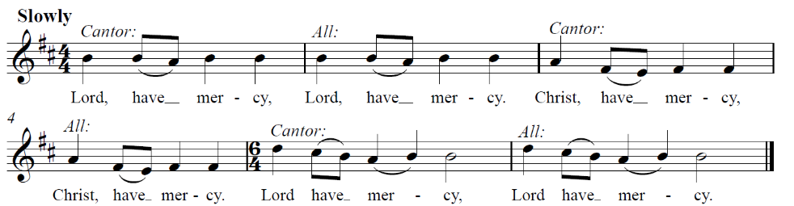

THE CONFESSION

Senior Server
The Lord has mercy on those who fear him from generation to generation.

Silence may be kept.

Let us humbly confess our sins in penitence and faith, confident that God will raise us up.

Merciful God,
our maker and our judge,
we have sinned against you in thought, word, and deed,
and in what we have failed to do:
we have not loved you with our whole heart;
we have not loved our neighbours as ourselves;
we repent, and are sorry for all our sins.
Father, forgive us. Strengthen us to love and obey you in newness of
life; through Jesus Christ our Lord. Amen.

THE ABSOLUTION

Celebrant
Almighty God, who has promised forgiveness to all who turn to him in faith:  pardon you and set you free from all your sins, strengthen you in all goodness and keep you in eternal life, through Jesus Christ our Lord. Amen.

GLORIA IN EXCELSIS

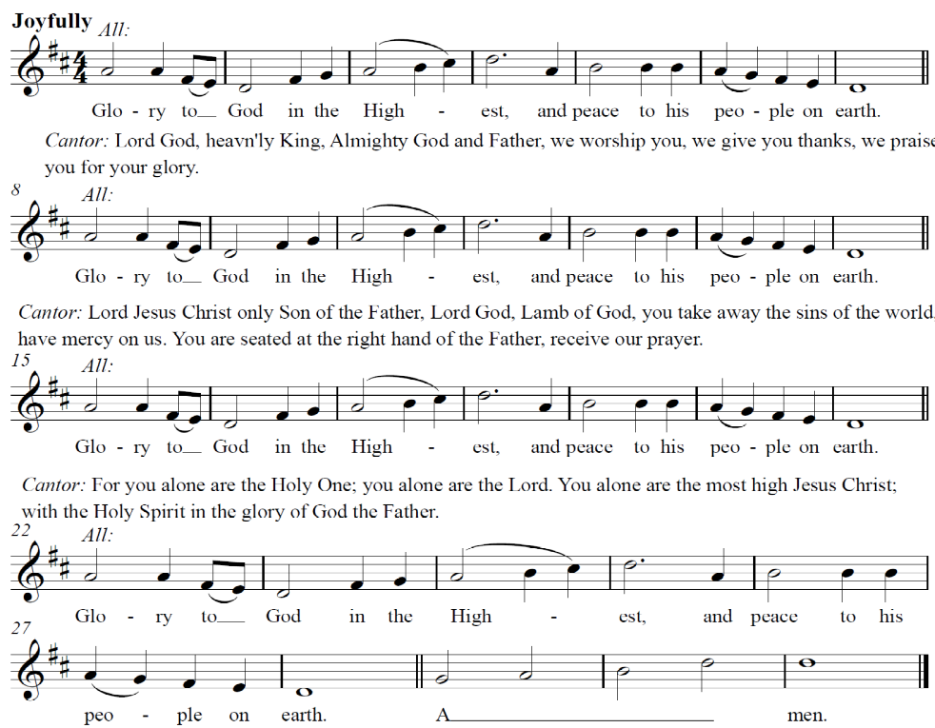
COLLECT OF THE DAY

Celebrant
Loving God,
who chose the blessed virgin Mary
to be the mother of your incarnate Son:
grant that we, who are redeemed by his blood,
may share with her in the glory of your eternal kingdom;
through Jesus Christ our Lord,
who lives and reigns with you, in the unity of the Holy Spirit,
one God, now and for ever.
Amen

THE MINISTRY OF THE WORD

Please sit

FIRST READING

A reading from the prophet Isaiah 61:10 - 62:3

¹⁰ I delight greatly in the Lord; my soul rejoices in my God. For he has clothed me with garments of salvation and arrayed me in a robe of his righteousness, as a bridegroom adorns his head like a priest, and as a bride adorns herself with her jewels. ¹¹ For as the soil makes the young plant come up and a garden causes seeds to grow, so the Sovereign Lord will make righteousness and praise spring up before all nations.
⁶² For Zion’s sake I will not keep silent, for Jerusalem’s sake I will not remain quiet, till her vindication shines out like the dawn, her salvation like a blazing torch. ² The nations will see your vindication, and all kings your glory; you will be called by a new name that the mouth of the Lord will bestow. ³ You will be a crown of splendour in the Lord’s hand, a royal diadem in the hand of your God.

Hear the Word of the Lord. Thanks be to God.

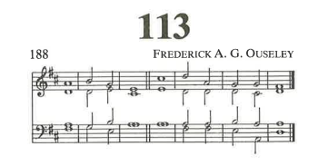
1 | Praise the Lord  O sing praises you that | are his | servants:  O | praise the | name • of the | Lord.
2 | Let the name of the | Lord be | blessed:  from this time | forward |and for|ever.
3 | From the rising of the sun to its | going | down:  let the | name • of the | Lord be | praised.
4 | The Lord is exalted over | all the | nations:  and his | glory • is a|bove the | heavens
5 | Who can be likened to the | Lord our | God:  in | heaven • or up|on the | earth,
6 | Who has his | dwelling • so | high:  yet condescends to | look on | things be|neath?
7 | He raises the | lowly • from the | dust:  and lifts the | poor from | out of • the | dungheap;
8 | He gives them a place a|mong the | princes:  even among the | princes |of his | people.
9 | He causes the barren woman to | keep | house:  and makes her a joyful mother of children|  Praise | –the | Lord.

SECOND READING

A reading from the letter of Paul to the Galatians 4:4 - 7
⁴ But when the set time had fully come, God sent his Son, born of a woman, born under the law, ⁵ to redeem those under the law, that we might receive adoption to sonship. ⁶ Because you are his sons, God sent the Spirit of his Son into our hearts, the Spirit who calls out, ‘Abba, Father.’ ⁷ So you are no longer a slave, but God’s child; and since you are his child, God has made you also an heir.

Hear the word of the Lord. Thanks be to God

All stand

GOSPEL ACCLAMATION

Cantor
Alleluia, Alleluia, Alleluia!

Alleluia, Alleluia, Alleluia!
My soul magnifies the Lord, and my spirit has rejoiced in God, my saviour. For He has regarded the lowly state of His maid servant, for behold, henceforth all generations will call me blessed.

Alleluia, Alleluia, Alleluia

Celebrant
The Lord be with you.

And also with you.

The Gospel of our Lord Jesus Christ according to Luke 1:46 - 55

Sung
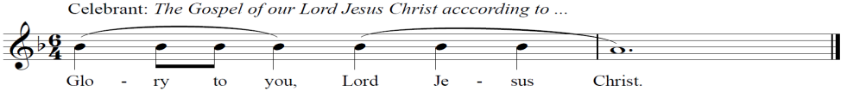

The gospel is censed with the prayer that God will place his word in our minds, on our lips, and in our hearts.

⁴⁶ And Mary said:
‘My soul glorifies the Lord
⁴⁷and my spirit rejoices in God my Saviour,
⁴⁸ for he has been mindful
of the humble state of his servant.
From now on all generations will call me blessed,
⁴⁹ for the Mighty One has done great things for me –
holy is his name.
⁵⁰ His mercy extends to those who fear him,
from generation to generation.
⁵¹ He has performed mighty deeds with his arm;
he has scattered those who are proud in their inmost thoughts.
⁵² He has brought down rulers from their thrones
but has lifted up the humble.
⁵³ He has filled the hungry with good things
but has sent the rich away empty.
⁵⁴ He has helped his servant Israel,
remembering to be merciful
⁵⁵ to Abraham and his descendants for ever,
just as he promised our ancestors.’

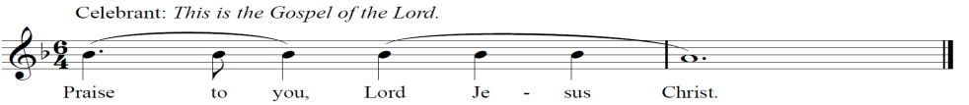
This is the gospel of the Lord. Sung Praise to you Lord Jesus Christ.

All sit

SERMON

HYMN Tune Stabat Mater

1 | At the Cross her station keeping,  Stood the mournful Mother weeping,  Close to Jesus at the last.  Through her soul, of joy bereavèd,  Bowed with anguish, deeply grieved,  Now at lengthy the sword hath passed.
2 | *O, that blessèd one, grief-laden,  Blessèd Mother, blessèd Maiden,  Mother of the all-holy One;  O that silent, ceaseless mourning,  O those dim eyes, never turning  From that wondrous, suffering Son.
3 | Who on Christ's dear Mother gazing,  In her trouble so amazing,  Born of woman, would not weep?  Who on Christ's dear Mother thinking,  Such a cup of sorrow drinking,  Would not share her sorrow deep?
4 | For his people's sins, in anguish,  There she saw the victim languish,  Bleed in torments, bleed and die:  Saw the Lord's anointed taken;  Saw her Child in death forsaken,  Heard his last expiring cry.
5 | In the Passion of my Maker,  Be my sinful soul partaker,  May I bear with her my part;  Of his Passion bear the token,  In a spirit bowed and broken  Bear his death within my heart.
6 | *May his wounds both wound and heal me,  He enkindle, cleanse, anneal me,  Be his Cross my hope and stay.  May he, when the mountains quiver,  From that flame which burns for ever  Shield me on the judgement day.
7 | Jesu, may thy Cross defend me,  And thy saving death befriend me,  Cherished by thy deathless grace;  When to dust my dust returneth,  Grant a soul that to thee yearneth  In thy Paradise a place.

THE NICENE CREED

Senior Server

Let us together affirm the faith of the Church:

All stand

We believe in one God, the Father,
the almighty, maker of heaven and earth,
of all that is, seen and unseen.
We believe in one Lord, Jesus Christ,
the only Son of God,
eternally begotten of the Father,
God from God, Light from Light,
true God from true God,
begotten, not made,
of one being with the Father;
through him all things were made.
For us and for our salvation
he came down from heaven,
was incarnate of the Holy Spirit and the virgin Mary
and became truly human.
For our sake he was crucified under Pontius Pilate;
he suffered death and was buried.
On the third day he rose
again in accordance
with the Scriptures;
he ascended into heaven
and is seated at the right hand of the Father.
He will come again in glory to judge the living
and the dead and his kingdom will have no end.
We believe in the Holy Spirit, the Lord,
the giver of life, who proceeds from the Father and the Son, who with the Father and the son is worshipped and glorified,
who has spoken through the prophets.
We believe in one holy catholic and apostolic Church.
We acknowledge one baptism for the forgiveness of sins.
We look for the resurrection of the dead, and the life of the world to come. Amen.

THE PRAYERS OF THE PEOPLE

Senior Server
Let us pray for the world and for the Church.

All sit / kneel

A Prayer for St Peter’s in 2023:
Almighty and eternal God, by whose Spirit the whole body of the church is governed and sanctified: graft in our hearts the love of your Name, nourish us with all goodness, prosper, by your Spirit, the work to which you have called us in this parish, and, by your grace, grow your church in Cremorne, with Christ as our cornerstone. Enable us, more and more, to worship you with all of our lives, grow in faith and love, share Jesus with our community, and rejoice in Christ together, for the honour of our Lord and Saviour, Jesus Christ. Amen.

Periods of silence may be briefly kept for personal prayer. Each petition ends with this response: Lord in your mercy, Hear our prayer.

Accept our prayers through Jesus Christ our Lord who taught us, to pray,

Our Father in heaven,
hallowed be your name,
your kingdom come,
your will be done,
on earth as in heaven.

Give us today our daily bread.

Forgive us our sins

as we forgive those

who sin against us.

Save us from the time of trial

and deliver us from evil.

For the kingdom, the power,

and the glory are yours,

now and for ever. Amen

PREPARATION FOR HOLY COMMUNION
All stand
Celebrant
Hear the words of assurance for those who truly turn to Christ:
Jesus said: Come to me, all who labour and are heavy laden, and I will give you rest. Matthew 11.28
God so loved the world that he gave his only Son, that whoever believes in him should not perish but have eternal life. John 3.16
We do not presume to come to your table, merciful Lord,
trusting in our own righteousness,
but in your manifold and great mercies.
We are not worthy so much as to gather up the crumbs under
your table.
But you are the same Lord whose nature is always to have mercy.
Grant us, therefore gracious Lord,
so to eat the flesh of your dear Son Jesus Christ,
and to drink his blood, that we may evermore dwell in him,
and he in us. Amen.

THE GREETING OF PEACE

All stand

Celebrant
We are the body of Christ.

His Spirit is with us.

The peace of the Lord be always with you.

And also with you.

All may exchange a sign of peace with a handshake and greeting, “Peace be with you”.

THE GREAT THANKSGIVING

Celebrant
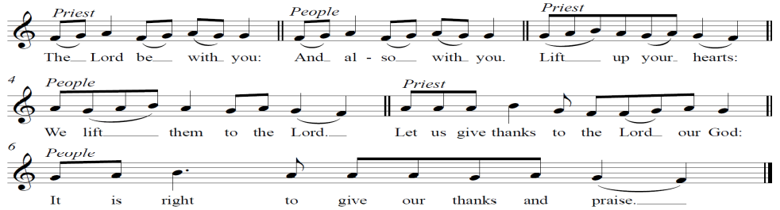

Celebrant
All glory and honour be yours always and everywhere, mighty Creator, everliving God.

We give you thanks and praise for your Son, our Saviour Jesus Christ, who was born and lived as one of us.

By his death on the cross and rising to new life, he offered the one true sacrifice for sin and obtained an eternal deliverance for his people.

And now we give you thanks for the obedience of your servant Mary, who by your graced answered your call to be the mother of your Son.

With all generations we call her blessed, and with her we rejoice in the greatness of your salvation.

Therefore with angels and archangels, and with all the company of heaven, we proclaim your great and glorious name, for ever praising you and saying/singing:
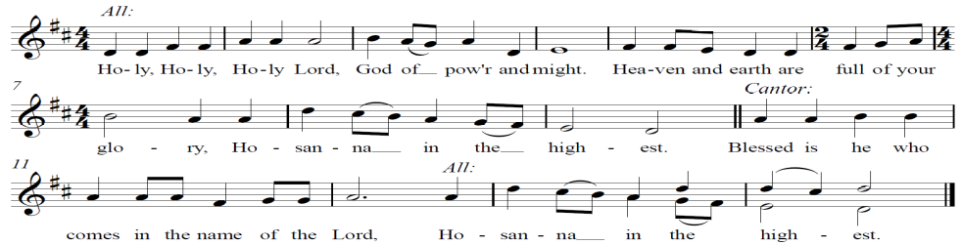
And now, gracious God, we thank you for these gifts of bread and wine, and pray that we who receive them, in the fellowship of the Holy Spirit, according to our Saviour’s word, in remembrance of his suffering and death, may share his body and blood.

On the night before he died, Jesus took bread, and when he had given you thanks he broke it, and gave it to his disciples, saying,
‘Take, eat. This is my body given for you.
Do this in remembrance of me.’

After supper, he took the cup, and again giving you thanks he gave it to his disciples saying,
‘Drink from this, all of you.
This is my blood of the new covenant
shed for you and for many
for the forgiveness of sins.
Do this, as often as you drink it,
in remembrance of me.’
Cantor
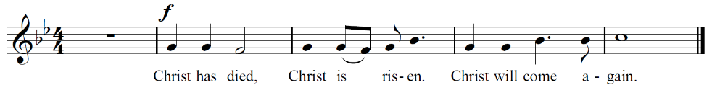
Let us proclaim the mystery of faith,

Father, as we recall his saving death and glorious resurrection, may we who share these gifts be renewed by your Holy Spirit and united in the body of your Son.

Bring us with all your people into the joy of your eternal kingdom, there to feast at your table and join in your eternal praise:

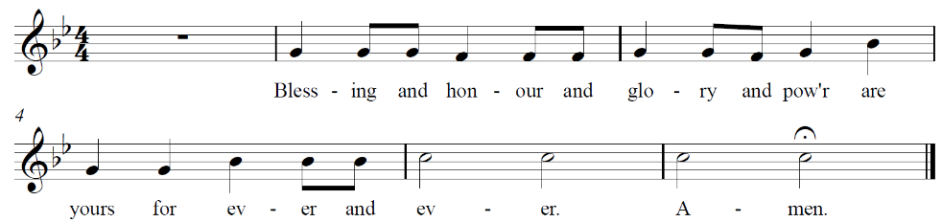

THE BREAKING OF THE BREAD AND THE COMMUNION

The celebrant breaks the bread.

As this broken bread was once many grains, which have been gathered together and made one bread:

So may your Church be gathered

from the ends of the earth into your kingdom.

AGNUS DEI

Cantor

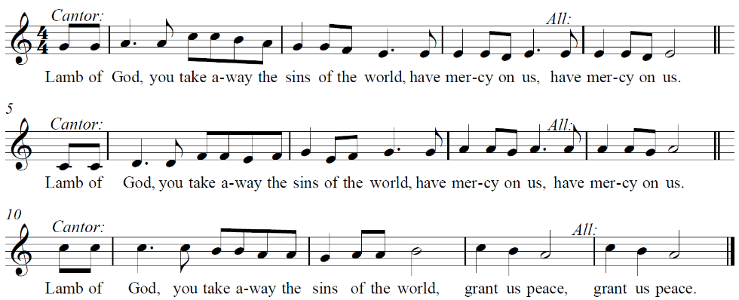

INVITATION

Celebrant
The gifts of God for the people of God.
Come let us take this holy sacrament of the body and blood of Christ in remembrance that he died for us, and feed on him in our hearts by faith
with thanksgiving.

As the sacrament is received the communicant responds. Amen.

All baptised Christians who love and serve the Lord Jesus are welcome
to join in the sharing of Holy Communion. If you are not yet ready to
receive Communion, we encourage you to come forward for a prayer of blessing. Please indicate your desire for a blessing by holding your hands behind your back.

After receiving communion, the congregation sits or kneels. Silence for prayerful reflection may be kept.

COMMUNION SONG

Cantor Franz Joseph Haydn.

When I think upon Your goodness,
And recall Thy tender care,
Then, O Lord, my heart confesseth,
How large Thy bounties are.
For Thy love it ever floweth,
Like the sea, it hath no bound;
When grief my heart was broken,
Then, O Lord,
I mercy found, I mercy found,
When grief my heart was broken,
Then, O Lord, O Lord,
I mercy found, I mercy found.

SENTENCE

Celebrant
I delight greatly in the Lord; my soul rejoices in my God.
For he has clothed me with garments of salvation and arrayed me in a robe of his righteousness. Isaiah: 61:10a

PRAYER AFTER COMMUNION

All stand

Celebrant
God our Saviour, your word proclaims our salvation which we taste in the bread of life. Grant us the humble obedience we see in Mary that we, too, may respond as willing servants and bear your Word to our world.

Most loving God, you send us into the world you love. Give us grace to go thankfully and with courage in the power of your Spirit. Amen.

PRAYER FOR OFFERTORY

Gracious God, all things come from you, and you teach us to be generous with what we have. We pray that our gifts may be wisely used for the ministry of the gospel and the relief of those in need, for the glory of our Lord Jesus Christ. Amen.
NOTICES

Please be seated

GOD’S BLESSING

All stand

Celebrant
Christ the Son of God, born of Mary, gladden our hearts by his coming to dwell among us, and fill us with joy and peace; the blessing of God almighty,  the Father, the Son and the Holy Spirit, be among you and remain with you always. Amen.

DISMISSAL

Senior Server
Go in peace to love and serve the Lord: In the name of Christ. Amen.

RECESSIONAL HYMN Tune: ii, Rievaulx

1 | Father of heaven whose love profound  a ransom for our souls hath found,  before your throne we sinners bend;  to us your pardoning love extend.
2 | Almighty Son, incarnate Word,  our prophet, priest, redeemer, Lord,  before your throne we sinners bend;  to us your saving grace extend.
3 | Eternal Spirit, by whose breath  the soul is raised from sin and death,  before Thy throne we sinners bend;  to us Thy quick'ning pow'r extend.
4 | Thrice holy - Father, Spirit, Son,  mysterious Godhead, Three in One,  before your throne we sinners bend;  grace, pardon, life to us extend.

ORGAN POSTLUDE

As a courtesy to those who remain in the church to listen to the organ voluntary in its entirety, you are encouraged to enjoy conversation and fellowship outside the building. The voluntary is a liturgical musical offering to God.
Parish Bulletin
WEEKLY PRAYER POINTS

FOR GOD’S KINGDOM
Lord our God, giver of all grace, have mercy on your Church throughout the world. Renew its life; restore its unity; sanctify its worship; empower its witness; and make it a fit instrument for the furtherance of Christ’s kingdom among all people, to the glory of his great name. Amen.

THE ANGLICAN COMMUNION
We pray for the Anglican Communion, for Justin of Canterbury, Geoffrey,
Primate of Australia, Kanishka our Archbishop and Bishop Chris and the Anglican Church of Chile.

ST PETER’S PARISH AND LOCAL CHURCHES
For our Rector Rev’d Tim St Quintin and our Assistant Minister Dan Gillis and our honorary associate Bishop Peter Watson. We also pray for the Catholic Parish of Sydney Harbour North – Sacred Heart Mosman, St Joseph’s Cremorne, Blessed Sacrament, and St. Therese’s Mosman.

PRAYERS FOR THE LOCAL COMMUNITY
For school and other places of education. Praise God as the source of all truth, and that many will come to know Jesus as the way, the truth, and the life. Pray that in our schools, kindergartens, colleges, universities and other places of learning, truth and wisdom may be pursued, prized, and celebrated. Pray that God would give teachers creativity, clarity and care, and students a love of learning and an openness to new ideas. Ask that God bless them with co-operation, fairness and, above all, a recognition that the world they study is created, sustained and redeemed by him. At Redlands, pray especially for Sean Corcoran – Principal; Fiona McKenzie and Kirsten Philips - chaplains, Sue Tymoszuk – Head of Christian studies, and the Christian Studies teachers. At Neutral Bay Kindergarten, pray for Nate and Maggie Wang, the teachers and children.

PRAYERS FOR THE WIDER WORLD
Pray for Niger following the coup, and other places of political instability. Pray for stability in the country as turmoil grows and rumours spiral on social media.
Pray for the church in Niger to be a light in these turbulent times. Pray this new regime would show mercy to the church in Niger. Pray that the protests will be peaceful and not escalate into violence.

OUR PARISHIONERS
Michael Awad, Michael and Antonia Badger, Roy Bartlett and Noreen and Ken Bernie.

THE SICK
Those requiring on-going prayer
Noel and Anne Blake, Cicely Bungey, Bobbie Dee Deal, Robin Dodd, Sarah Gordon, Edwina Lambkin, Marty McCallum, Michael Pollak, Gill Stemp, Susan Upton, Anne Vernon, Gigi, Helen, Janne, JJ, Pamela, Margie & Rein, Jane, Jenny and Sally, Louise and Russ McLean and Lyn and Caroline Bowyer.

Those in residential care
Fr Robert Alexander, Glenyth Burrus, Judy Chapman, Kathy Moss, Patricia Reuben, Stan Thomas, Helen Ramsay.

FAITHFUL DEPARTED
We praise God for his faithful servants in every age. We pray that we,
with all who have died in the faith of Christ, may be brought to a joyful resurrection and the fulfilment of God’s eternal kingdom.

We remember the recently deceased and we also remember those whose anniversary occurs at this time especially Ronald Horne.


AUGUST 2023
Tuesday 15 | 10am | Table Group Café Laon  Anna is the contact
 | 10.00am | Eucharist and morning tea
 | 10:30am - 12 | Crafters Group
 | Will not meet this week | Table Group, Rectory,  Bronwyn is the contact
Wednesday 16 | Will not meet this week | Table Group  Rev’d Tim is the contact
Friday 18 |  | Rev’d Tim’s day of rest

RECTOR AWAY FROM THE PARISH
Tim and Sarah will be away at a ministry conference from Tuesday 15 - Friday 18 August. For pastoral care needs, please contact one of the pastoral care team; for other matters, please contact one of the Wardens.
DAN GILLIS ON LEAVE
Dan will be on leave 7th – 22nd August.
ROSTERS: OCTOBER – DECEMBER 2023
I will be working through the October- December service rosters over the next few weeks. Can you please let me know your availability during this time? If you would like to be added to serve let me know, new volunteers are always welcome. - Anna Reed-Stephenson (reed_stephenson@hotmail.com)



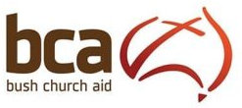
MISSION OF THE MONTH – BUSH CHURCH AID
NEXT SUNDAY - 20 AUGUST

Guest Preacher
The Rev'd Paul Sampson, General Secretary of BCA in NSW will be with us.

Prayers
Reminder to keep the Boardman family in our prayers.

Retiring Collection
We will have a retiring collection for BCA at the entrance to the church.

Mini Cake Stall
We will have a mini cake stall in the DA Room after the service. Proceeds to BCA . All donations of home-made goods always appreciated.

Bush Church Aid is supporting the ministry of The Rev'd James Boardman and Charly at All Saints Cathedral, Bathurst. As the Boardman’s left our parish to move to Bathurst, this is an opportunity to
support their outreach.

Edwina Waddy – Mission Secretary

SUNDAY ROSTERS

 | This week  13 August  Mary Mother of our Lord | Next week  20 August  Pentecost 12
First Reading | Isaiah 61:10 | Genesis 45:1-5
Psalm | Psalm 113 | Psalm 133
Second Reading | Galatians 4:4-7 | Romans 11:13- 36
Gospel | Luke 1: 46-55 | Matthew 15:10-28
Preacher | Kirsten Phillips, Redlands | Rev’d Paul Sampson  Bush Church Aid
Celebrant | Tim St Quintin | Tim St Quintin
Service Leader | Tim St Quintin | Tim St Quintin
Senior Server | Laura Mock | Roy Bartlett
Crucifer | Gordon Heathcote | John Halford
Thurifer | Roy Bartlett
Acolyte | John Halford
 | Taylor Mock
Welcomer | Noreen Bernie  Bronwyn Lihou | Barbara Gordon  George Paul
Reader | Barbara Gordon | Barbara Gordon
 | Ken Bernie | Suzanne Paul
Intercessor | Ruth Cohen | Esme Parker
Chalice | Bronwyn Lihou | Stefan Trofimovs
Livestream | Daniel Bastock | Taylor Mock
Morning tea | Anna Reed-Stephenson  Audrey Bradshaw | Graham St Quintin  Lizzie St Quintin
Sacristy Linen | Alison Peterson | Kerry Trofimovs

PARISH DIRECTORY
29 Waters Road Cremorne NSW 2090
Tel [02] 9953 1050
www.stpeterscremorne.org.au

Rector | Rev’d Tim St Quintin | 0401 289 919
Assistant minister | Dan Gillis | 0405 972 039
Honorary Associate Minister | Bishop Peter Watson
Churchwardens | Russell Layton | 0417 065 989
 | Anna Reed-Stephenson | 0475 802 906
 | Helen Matheson | 0400 351 837
Hon Treasurer | Peter Smith | 0418 409 780
Parish Councillors | Ben Austin | 0478 128 920
 | Norman Reynolds | 9452 1520
 | Prabhu Boddu | 0435 468 411
 | David Cohen | 0418 205 534
 | Laura Mock | 0405 121 312
 | Geoffrey Thipthorp | 0420 560 552
 | Philip Wood | 0438 675 501
Director of Music | Glenn Amer | 0414 238 725
Safe Ministry Rep | Annabel Pegus | 0418 672 261
Pastoral Care Contacts | John Halford | 9411 5971
 | Sue Paul | 0407 477 270
 | David Routley | 0429 092 783
Mission Secretary | Edwina Waddy | 0402 116 216
Church Administrator | Rebeccah Finnegan | 9953 1050
Office hours: 9am – 2pm Tuesday & Thursday
Banking details for direct donations:
Name of account - St Peter’s Anglican Church Direct Donations
BSB 032 197, Account No – 224230

1995 The Anglican Church of Australia Trust Corporation. From the text of
A Prayer Book for Australia, published under the imprint of Broughton Books. Reproduced with permission 2003. All Bible readings are taken from the Holy Bible, New International Version® Anglicized, NIV® Copyright © 1979, 1984, 2011 by Biblica, Inc.®
Excerpts from the A Prayer Book for Australia are printed here with permission from Broughton Publishing Pty Ltd, the publishing arm of the Anglican Church in Australia.

